Chapter 13, Problem 24.

In the circuit of Fig. 13.93,

(a) find the coupling coefficient,

(b) calculate v_{o},

(c) determine the energy stored in the coupled inductors at t = 2 s.

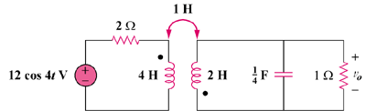

Figure 13.93
For Prob. 13.24.

